Source 1: Map of Europe
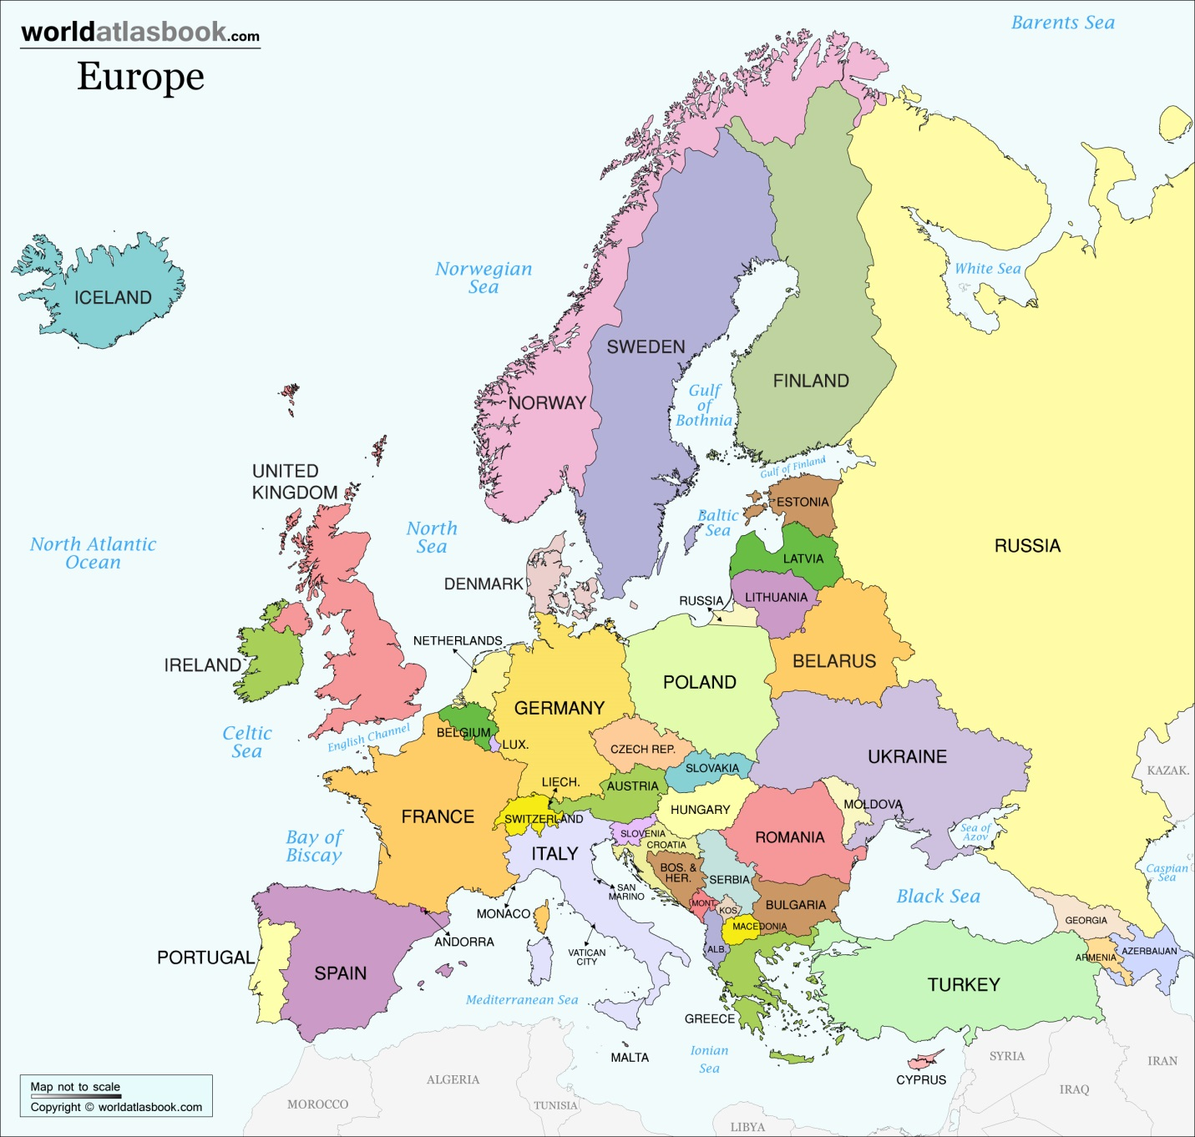
Country | Population  (per millions) | Area (km²) | Population density (people/km²)
Italy | 58.8 | 301 320 | 195
Austria | 8.3 | 83 858 | 99
Cyprus | 0.8 | 9 250 | 84
Bulgaria | 7.7 | 110 912 | 70

Source 2: European Seismic Hazard Map
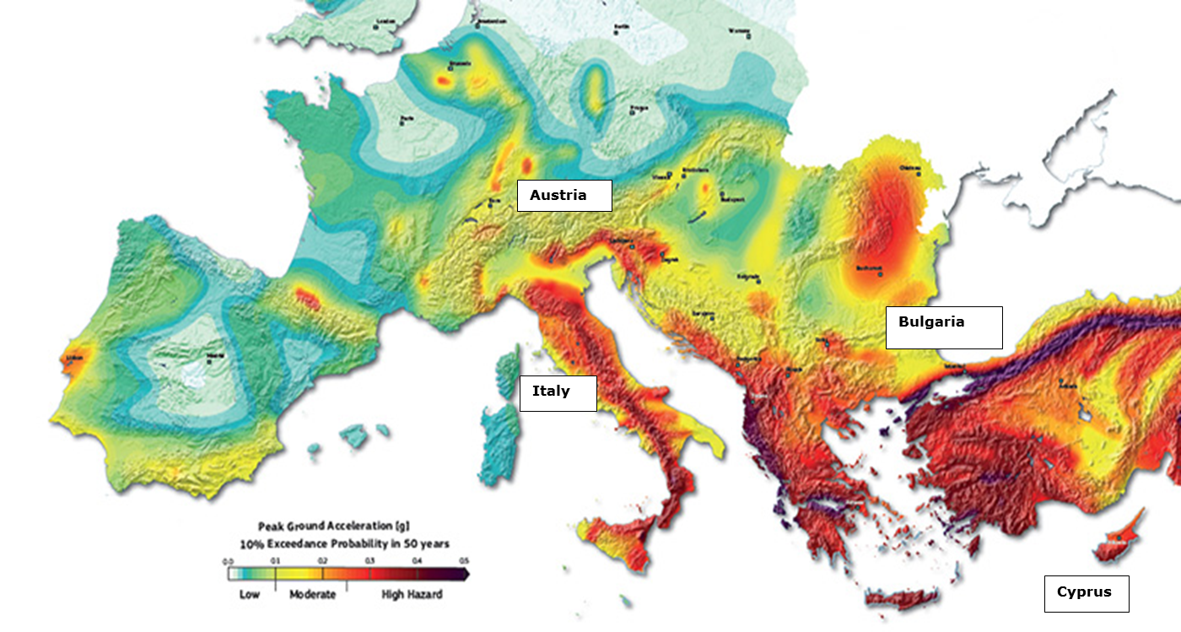

Source 3: Digital Economy and Society Index 2015

Source 4: Terror threat level in Europe
The British Foreign Office uses four ratings when considering the threat of a terrorist attack: high (deep red), general (red), underlying (orange) and low (yellow).

Source 5
Extreme weather conditions in Europe 1980 – 2013
Extreme weather conditions | Country | Effects | Predictions for the future
Very high temperatures | Central & Eastern Europe (2003-2010) | Death from the devastating heat  Wildfires  Drought | Increase of devastating heat
Intense Rainfall | Germay, Hungary, United Kingdom, France, Italy, Spain | Floods | Increase of floods in Poland, Germany, Austria, Switzerland, France and Italy
Windstorm | Northeastern & Central Europe | Hail  Tornadoes  Thunderstorms | Increase in Northeastern & Central Europe

New European Climate Map 2071 - 2100
Mediterranean Countries
The temperature overcomes the average.
The annual rainfall is decreased.
The annual river flow is decreased.
The risk of droughts is increased.
The risk of wildfires is increased
The deaths due to devastating heat are increased.

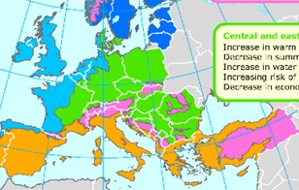
Central & Eastern Europe
Extremely high temperatures
The annual rainfall is decreased in the summer.
The water temperature is increased.
The temperature overcomes the average.
The snowfalls are decreased.
The risk of wildfires is increased.

Highlands
The temperature overcomes the average in Europe.
The ice volume and area are increased.
Permafrost areas are increased.

Mission
- Read your CV.
- Read the location parameters for the construction of the nuclear power plant.
- Read the sources according to each parameter.
- Use the table below in order to rate each parameter in each country as follows:
1 Not suitable at all
2 A little suitable
3 Partially suitable
4 Suitable
5 Quite suitable
- The country with the highest score will be selected as the most suitable for the construction of the nuclear power plant.

Remember that you have to rate each parameter based on your expertise!

Do not forget to rate each criterion as ……………………….

Parameters | Italy | Austria | Cyprus | Boulgaria
Parameter 1
Parameter 2
Parameter 3
Parameter 4
Parameter 5
Score

Group ………………………………….
The country with the highest score recommended as the most suitable for the construction of the nuclear power plant is ……………………………because……………………………………………………………………………………………………………………………………………………………………………………………………………………………………………………………………………………………………………………………………………………………………………………………………………………………………………………………………………………….

Name: Mark Mineral
Profession: Geologist
Studies: Bachelor & Master degree in geology
Subjects in high-school: physics, computer science, mathematics, chemistry, biology

Job description: The geologist explores the Earth, as a doctor uses his tools and techniques to examine the human body. He is trying to understand how the earth works and discover natural resources such as water, minerals and oil which are useful for our daily life.
The geologist, also, collaborates with scientists from other disciplines (environmentalists, engineers to build airports, tunnels, dams, harbors etc.). In this case, geologist must conduct geological and geophysical studies, analyzing and interpreting data and providing useful information (e.g. for choosing a location for a construction). This job may take place either in the office or outdoors.

Basic job requirements:
- Computer skills
- Computational and mathematical skills
- Observation and analysis skills
- Perception of various forms and shapes
- Use of computer-based tools (e.g. Geographic Information Systems (GIS)
- Interpersonal relations and communication: collaborates with other scientists.
- Physical stamina: Sometimes geologists work under difficult weather and natural conditions.

Name: Erin Green
Profession: Environmentalist
Studies: Bachelor degree in environmental science & Master degree in environmental engineering
Subjects in high-school: physics, mathematics, chemistry, biology

Job description: The environmentalist deals with issues related to environmental protection, management and recycling. Specifically, she identifies and studies environmental problems and trying to find ways to minimize the risks either for the environment or for the people. For instance, he gives answers to questions such as “Does the air pollution from the exhaust gases may not affect only humans health?” or “How can an oil spill cause damage fishes and aquatic plants?”.
In collaboration with her colleagues, analyzes measurements of air, food, water, soil and determine ways of how to keep clean and protect the environment. She often assesses the risks, i.e. describes the possible consequences that may have the construction of buildings or other environmental changes, compose reports, make presentations to the stakeholders and review the given permissions in order to conduct various activities that may have negative impact on the environment.

Basic job requirements:
- Care for the environment
- Sensitivity and interest in topics about the environment protection
- Understand and assess environmental conditions
- Continuous update about the problems caused by human activities
- Analytical thinking
- Communication skills in order to inform stakeholders
- Argumentation skills in order to convince or to propose alternative ideas
- Language skills

Name: Αnn Watery
Profession: Hydrologist
Studies: Bachelor degree in Hydrology and Water Resources Management & Master degree in Hydrology
Subjects in high-school: physics, mathematics, chemistry, biology

Job description: Hydrologist examines physical characteristics, the distribution and the circulation of water above and below the earth’s surface. They study rainfall and other precipitation, the paths precipitation takes through the soil and rocks underground, and its return to the oceans and air.
In order to study, he requires instruments like telescopes and other models to keep track of changes. It can be used sensitive devices to estimate the water flow and quality on the surface. For example, he can collect and assess data in order to determine the level of water pollution, predict a drought or a flood (from ice in the mountains).
Hydrologists often serve as consultants to scientists, engineers, developers, and governing bodies. They may study the feasibility of water reclamation or routing projects, or they may determine the possible effects of activities such as drilling, land development, and bridge construction on local waters and the construction of nuclear power plant.

Basic job requirements:
- Excellent computer skills
- Communication skills
- Ability for hard work in distant areas
- Collaboration skills with other scientists
- Analysis skills

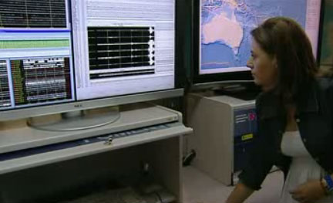
Name: Mary Richter
Profession: Seismologist
Studies: Bachelor and Master Degree in Physics and PhD degree in Geophysics
Subjects in high-school: physics, mathematics, biology, computer science

Job description: Seismologist studies earthquakes and her investigation is intended to interpret geological composition of the Earth (constituent components). Studying earthquakes can assess possible risks and put an effort to minimize their impact by suggesting changes or improvements on building constructions specifications.
She checks and records seismic activities occurring both in her country and all over the world in order to find out the origin, type and size of the earthquake. Seismologist protects citizens by providing useful material such as maps with seismic zones and giving tips what to do in case of an earthquake.
Basic job requirements:
- Excellent computer skills and use of computer-based tools (e.g. efficient use of seismograph)
- Great interest in geophysics
- Conduct research in the field
- Ability to represent two-dimensional drawings into three-dimensional
- Willingness to travel to various locations
- Patience and methodical
- Collaboration skills with other scientists
- Communication skills

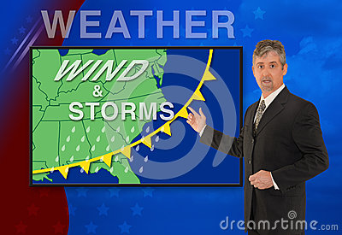
Name: Richard Weathery
Profession: Meteorologist
Studies: Bachelor degree in Physics, Master degree in Metereology
Subjects in high-school: physics, computer science, mathematics, chemistry, biology

Job description: Richard has other responsibilities except from the weather forecast in the news at 8:30 p.m. He studies the measurements and the atmosphere movement with special instruments in order to predict the weather. The weather forecast helps people to protect themselves (e.g. shipping, air transportation).
Meteorologist studies the atmosphere and attempts to identify and interpret climate trends, in order to understand past weather conditions and analyze current weather conditions. For example, he can study a hurricane path and help people to protect. Have you ever seen weather balloons in the sky? Richard uses these balloons in combination with other tools, physical and mathematical relationships to study the air pressure, temperature, humidity, wind speed in order to make predictions. According to these predictions, he proposes ways to address extreme weather events.
Basic job requirements:
- Computer skills (e.g. handling computational models)
- Enthusiasm for weather events
- Analysis skills
- Ability to make weather forecasts
- Ability to transfer scientific result into simple and understandable language

